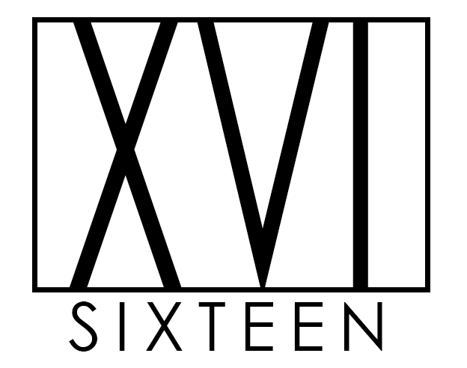

**Table of Contents**

1. Executive summary
2. Introduction
3. Team Information / Introduction to XVI / Meet the team at XVI / Meet team XVI
4. Tools Ness - done
5. Industry Data Report Ollie
6. IT technology reports
   1. Raspberry Pi – Nat - done
   2. Cloud services and servers – Josh
   3. Cyber Security – Connor
   4. Machine Learning – Corbin
7. Project: Elderly engagement app
8. Feedback?
9. Group reflection?
10. References

**Executive summary**

**Introduction**

**Meet the team at XVI**

**Tools**

As a group we have used a variety of tools in order to complete the tasks required, we have collaborated daily via Discord chat and caught up frequently throughout the week via Discord voice chat. In doing so, this has enabled the team to engage on a personal level which then allows us to be ourselves and work comfortably in a team. Initially we used Google docs to collate data for our assignment, and after which we transitioned over to GitHub to ensure transparency and accountability.

Some of which include Discord, Photoshop, GitBash and GitHub, VCS and Microsoft word to name a few.

**\*\*More to add still… to be refined!\*\***

**Industry Data**

**Interview with an IT professional**

As we are in the early stages of our learnings of Information Technology, whatever that may be for each of us, it is invaluable to gain insight from individuals working within the IT sector on what their job looks like day-to-day and the challenges they face. I had the pleasure of interviewing Grant, a Senior Solutions Engineer at Intuit Australia Pty Ltd.

**What does the job of a Senior Solutions Engineer look like?**

I perform customer research and get involved in the design of solutions and their implementation. I also regularly present to clients and produce materials to help educate them on emerging technologies, industry trends and how our company is working with these to stay at the forefront in our industry.

***“****The pace of change has become so fast that it is very difficult to stay on top of everything new****”***

**Who do you interact with to accomplish projects?**

I spend a lot of time interacting with clients to understand their needs and capture their feedback on newly developed features. I also interact with my colleagues (predominantly software engineers, but also designers, product managers, sales managers, and others) to collaborate on solutions.

**Where do you spend most of your time?**

It depends on what phase of a project I am in. In the planning phases, I spend the most time interviewing clients and consolidating research. When it comes to implementing a solution, I will spend a lot of time alone programming with regular short meetings with other engineers.

***“****The one thing that is really important is to never stop learning*

*– it’s important to stay up to date****”***

**What aspect of your position is most challenging?**

Keeping up to speed on the latest technologies has become more difficult as my career has progressed. There are a lot more frameworks available now and while they provide great efficiencies, but they require a big commitment to learn. The pace of change has become so fast that it is very difficult to stay on top of everything new.

**Do you have any advice for graduates?**

There are so many opportunities in IT. I was worried early in my career that I was tiring of it, but it is so easy to pivot and get involved in different areas. The one thing that is really important is to never stop learning – it’s important to stay up to date, so if you find you’re not passionate enough about something you’re working it, see how you can pivot to be learning about things that do interest you.

As a Senior Solutions Engineer, Grants days are ever-changing dependent on the project they are working on and the phase they are currently in. Grant has the luxury of working closely with the end-user to understand their pain points of the software and the real voice of customer. Grant essentially works to figure out a solution that will improve their overall experience.

Throughout the interview with Grant, it became apparent that the progression of the IT sector impacts all IT professionals significantly and that it is of utmost importance to continuously stay up to date with current trends and to never stop learning.